CMALT Update

CMALT Update 1

Original CMALT application 1

Summary of recent work/practice 1

Overview of CPD activities over the past 3 years 2

BCS course on Risk management. 2

Reflection 3

ALT-C 3

Reflection 3

Evidence 4

E-assessment 6

Reflection 6

Evidence 6

MOOCs 7

Reflection 7

Updated future plans 7

New Submission Confirmation 7

Original CMALT application

The original CMALT application can be found at <https://sites.google.com/site/tomnfeportfolio/home>

Summary of recent work/practice

Recent work has involved several strands, of which the three most important have been project managing the implementation of Moodle including migration from Blackboard, supporting the use of e-assessment and the use of analytics to enhance the learning experience.

The Moodle project involved the migration from Blackboard to Moodle at Queen Mary, University of London (QMUL) and included the implementation of Moodle (including integrating it with other systems at QMUL), design work to make the interface more suited to the teaching at QMUL, migration of existing courses and staff development.

I have been working with a variety of colleges and universities to address concerns over the quality of feedback to students, and the students' engagement with the feedback (i.e. moving from feedback to feedforward or dialogic feedback). This has included helping them to identify opportunities for using feedback and ways in which feedforward can be incorporated into teaching practice as well as training in the use of a number of tools that can be used such as Grademark, Peermark, Screencast-o-matic, WebPA amongst others.

Analytics is of increasing importance, though care is needed to ensure that the data being used is appropriate and being used appropriately. I have helped universities to identify potential data sources, consider their meaning, think about the ethical issues, consider who should be involved and look at good practice. I was also involved in the JISC funded activity data programme, synthesising the results, which can be seen at http://www.activitydata.org.

Overview of CPD activities over the past 3 years

My CPD has taken many forms over the past few years, and before looking at three examples it is worth reflecting on my approach. My CPD has been driven by a combination of

* curiosity
* where I believe work opportunities may open up and
* client requirements.

On top of this I am also actively engaged with ALT-C both as a member of the programme committee (which gives me the opportunity to see a broad cross section of what is happening in the community) and attending conference, where I try to mix sessions that build on what I already know and finding new things.

Much of my CPD takes the form of following a number of blogs and twitter feeds and following up the interesting links that are posted on the latter. While this may not sound systematic by careful choice of the people (and bodies) that I follow and the subjects that pursue this does become reasonably systematic. I might add that I rarely read journal articles that are not open access as they all seem to cost around £40-45 as I am not affiliated to a university, and I have yet to read an article that I would consider worth that much. I do sometimes email authors for copies.

I also attend a number of British Computer Society (BCS) courses and talks and have been taking MOOCs too.

I find that some of the most powerful learning comes from odd snippets of conversation that lead me think and research more into the topic. To take a single example someone (I think it was Oleg Liber) said to me in the context of using analytics to improve success that "what counts as success for an institution may not be the same as success for the individual", and that one needs to be careful what one is trying to do. While obvious, I had not applied this to my work on analytics, but it made me stop, think, read some of the radical writings around the subject and I have since made sure that my work on analytics includes discussions on the ethical issues as well as pragmatics, technology etc.

BCS course on Risk management.

In November 2010 I attended the British Computer Society's autumn school on risk management (receipt below - if I ever had a certificate of attendance I have lost it). As shown the course was over four evenings and covered a variety of issues relating to risk management. Much of the discussion centred around the very largest projects, but there were many useful ideas that came from it, perhaps the most interesting was a method for managing projects based on the risk register, rather than for instance a Gantt chart. It certainly leads to some interesting ideas on how to manage projects, though putting it into practice can be problematic as it requires the support of management to take a different approach, which they are not always comfortable with. There is also the problem that whilst often being risk averse do not see this as an appropriate way to manage projects. Another problem that I have had with it is the reliability of the risk register, which is often at best patchy. The approach requires associating a cost with rectifying problems should the risk occur, and then using ones efforts to minimise the sum of (cost * likelihood) of all risks. First, in my experience it is impossible to identify all the risks (especially the "black swans" - <http://en.wikipedia.org/wiki/Black_swan_theory>), second it is problematic to determine their likelihood and third it is difficult to know what the cost of recovering is likely to be for either the project or the organisation. This has meant that I have only ever partially applied the idea to my practice. Fourth, it can be difficult to incorporate into Prince 2, depending on how that is being used.

I would like to try to do it more formally, but it would require the support of management and the ability to quantify the risks (ideally in pounds). Even so, it has made make much better use of the risk register than I had before.

I have also attended a variety of other BCS PROMS-G events to continue to develop my project management skills, especially in the area of agile projects as I think that this is an important way to go when there is considerable uncertainty, and is an alternative approach to managing risk.

Reflection

Having tried to apply some of the ideas from the course has not always been easy. First, the environment (or ones manager) has to be conducive to such methods and secondly the risk register has to be realistic. I have found that this is the greatest problem. Often the most important risks are not included either because there is no easy way to ameliorate them and therefore it is not acceptable to discuss them or they are simply politically not acceptable. This has meant that to apply the ideas I have sometimes had to have a public risk register and a private risk register with the risks that are not mentionable in it, and possibly more realistic costs of remediation.

While the ideas are sound, and it has improved my project management it is important to be realistic about how far it can be applied in an environment that will not see some risks as being real or acceptable. Thus there is often a problem with applying good practice. I have also become more up front about what I think the real risks of projects are, and the costs of putting things right. I have also found that for some people it can be better to express the cost as time (person days / weeks / months) to put things back on track then to express it as money. Of course the two can easily be equated, and it does worry me when managers are unwilling to do this. Perhaps that is a risk in its own right.

ALT-C

I have attended ALT-C for many years as part of my CPD. I have also served on the programme committee, which I consider to be an important part of the CPD.

I always try to choose a mix of topics which I know something about to extend my knowledge and some which are new to me. I find that participating in the programme committee (especially the meeting to look at the sessions) allows me to get a broad view of the areas that of particular interest, and new areas that coming up. One often sees a surge of papers on a hot or about to be hot topic (e.g. open badges), this helps me to see where new opportunities may arise.

It is also an opportunity to meet a wide variety of people (both old and new) working in the field and learn about the issues that they see as particularly important, and of course to raise my profile.

Finally it can be useful to see the results of research, though to be honest the results are often very narrow and of little significance (at least to me).

Reflection

This year I hit lucky and only had one bad session.

I looked at some areas that I have typically avoided as being outside my interest; notably video and went to two presentations that were both excellent and made me appreciate that I need to start to create and edit some videos - time to get my flip camera (it was a present I would never have bought one) or phone out I guess, learn some tools and understand how to start making videos. I also need to think about how they are used in learning. I have rarely used them as on the whole I prefer to read, but have been undertaking some MOOCs where video is an important part of the experience and the transcripts where available miss the slides etc.

While I do learn things in the formal sessions, and sometimes I am able to apply them directly (for instance I was at one session looking at ways of editing videos that I have tried out) I find it is the ideas that bubble up that are most useful. For instance, the ideas in Audrey Watter's keynote were not directly applicable, but enable me to put a new twist on the way that I address some issues.

Whereas a few years ago ALT-C was largely about the excitement of the new, with many papers on the latest gizmo or idea there has been a significant move towards effective use of technologies. I consider this to be helpful as most staff will not be wanting to use the latest technology (which may disappear and is fairly high risk as its effectiveness in education is unknown). Indeed, most staff still do not use VLEs effectively, and therefore work on encouraging greater engagement with the possibilities may be one of the most important areas, so I was pleased to see some papers that related to this. Of course, much of that is context specific (institution, subject, level, topic, lecturer etc), but having some new examples to point people at is always good.

Evidence

Sessions attended at ALT-C 2014

Monday

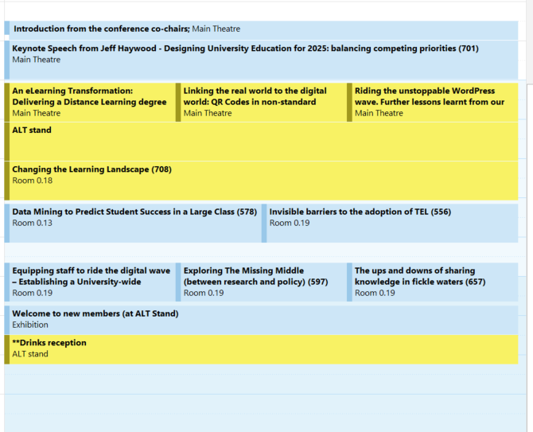

Tuesday

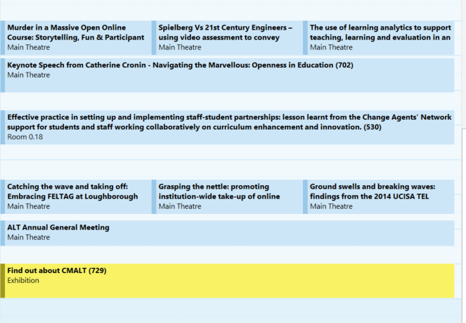

Wednesday

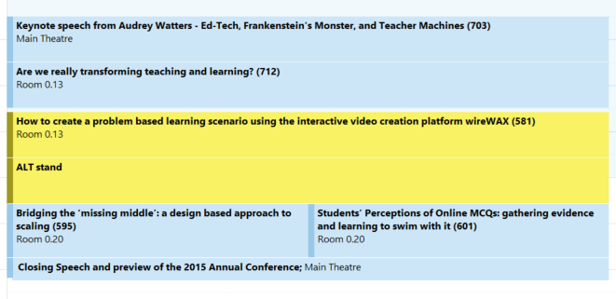

NB those highlighted in yellow were commitments (chairing or speaking)

E-assessment

My approach to this has been through informal learning; reading the literature, following blogs, discussing it with people and trying things out.

There is a huge body of evidence that feedback is one of the most powerful tools to support learning that exists, especially where students engage with it (feedforward, dialogic feedback), and that this can be supported by the appropriate use of technology. My study of this has been both theoretical, engaging with the literature, and practical learning the tools so that I can provide training and support that is soundly based and effective.

On the theoretical side the main things that I have been considering are:

* The importance of providing feedback that leads to action on the part of the student.
* Building in processes to ensure that feedback is useful (the NUS charter [http://www.nusconnect.org.uk/asset/news/6010/FeedbackCharter- toview.pdf](http://www.nusconnect.org.uk/asset/news/6010/FeedbackCharter-toview.pdf) and principles <http://www.nus.org.uk/cy/advice/course-reps/feedback-what-you-can-expect-/> form a good start point for discussion).
* considering the purposes of feedback such as:
  + Understand what students know
  + Measure students’ progress
  + Inform Students’ learning
  + Certificate students
  + Assess institutions
  + Assess teaching
  + I have also learnt several tools including in sufficient detail to be able to provide training in their use:
  + Turnitin's Grademark
  + WebPA (to enable students to say how much they have contributed to group work)
  + Audio feedback tools such as Screencast-o-matic

Reflection

Assessment and feedback is a huge topic, of which I have only scratched the surface on both the theoretical side and the effective use of tools, however I have explored it in sufficient detail to be able to provide useful training to a wide variety of clients in further and higher education. Using informal methods of learning has had some benefits for me. I have been able to fit it around my other commitments. I have been able to concentrate on areas that are particularly useful in my work, but this also means that there are important areas that I have not explored in detail as I have not needed them. One area that I feel could benefit from further study is the way in which feedback relates to different pedagogic models. Whilst it is explicit in some (Behaviourism for instance) in others I am not confident in how exactly it fits into the pedagogic framework (Constructivism for instance). That is not to say that I do not understand how it can be usefully applied and used to support a wide variety of different pedagogies, simply that in my study I have not come across formal mappings of this, and it is an area that I would like to pursue.

Evidence

Rather than evidence of learning this is evidence that I have learnt, and that I am able to teach it.

1. slides for training session

2. handout on how to use Grademark

3. Handout on how to use Screencast-o-matic

MOOCs

I have participated in several MOOCs and participated in and supported the OcTEL MOOC run by ALT. This has provided me with a both training in Web Science and Learning Technology (two of the MOOCs that I have completed) and a view of how MOOCs are run through undertaking others, including the very first MOOC run by Siemens and Downes.

Reflection

Having participated in maybe 8 or 10 MOOCs and completed four I have been able to consider both my own response to them and their more general applicability. For me they are low cost, low risk ways of engaging with a subject that either directly relates to my work, or is simply of general interest. Completion has been largely dependent on how well the MOOC works for me. In many cases I have given up because the teaching has been didactic and the discussion unfocussed. The ones that I have enjoyed the most have involved real discussions, rather than lots of people simply posting ideas and no real responses to them. As a result I have concentrated my efforts on responding to other people's comments rather than starting new topics, and I have found this much more fruitful, especially if I include questions in my comments.

As to the content itself, OcTEL offered little that I did not already know or do, though there were a few ideas that bubbled through, and some nice summaries of ideas that it can be useful to revisit. The Web Science one also offered little that I had not already covered elsewhere, but brought together some ideas in new ways that gave me insights, and some useful for my work in analytics.

Updated future plans

I intend to continue in a consultancy role for now, and this will mean following the fashions and trends, and staying up to date. However, increasingly I am using my role as a consultant to ensure that interventions are pedagogy rather than technology led, and I hope to be able to continue with this.

Should a suitable role open up then I will apply for a permanent position.

New Submission Confirmation

The above submission is honest and fair.



6 November 2014